Hotel Management System

Assume Antra has a client, which needs an application for Hotel Management. Application must be developed with technologies Angular, .Net Core Web API, Entity Framework Core, SQL Server Database. Clients needs the following operations in the application.

# Roomtypes: -

Should be able to Add/Update/Delete/List the Roomtypes. Room types could be Deluxe, Super Deluxe etc.

# Rooms: -

Should be able to Add/Update/Delete/List the Room. Status column should show if a room is available or not. If a room is already occupied, then it should not be booked again if it is occupied.

# Customers: -

Should be able to Add/Update/Delete/List the Customers. Assume that a customer can book only one room at a time.

# Services: -

Should be able to Add/Update/Delete/List the Services. Services will be linked to the room and are billable.

Below is the database design for the application. All primary keys should be automatically incremented value.

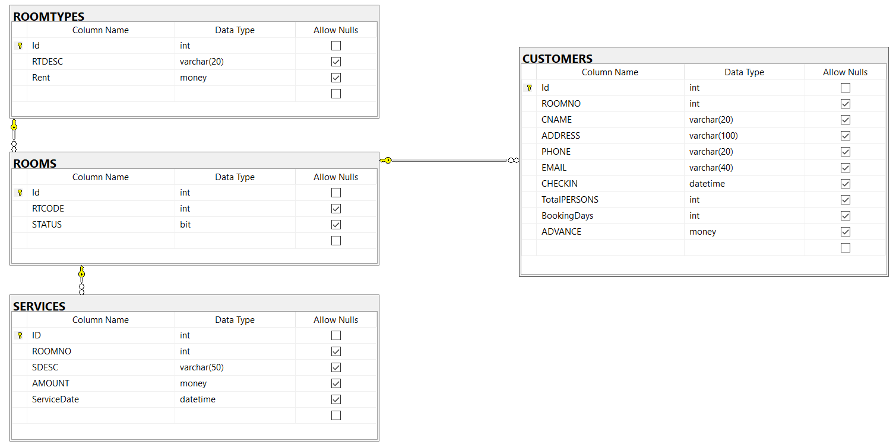

Guidelines:

1. Design the UI in Angular (Bootstrap 4 and ngBootstrap) home page should display Dashboard of Customers and customer name should be clickable that should show all the bookings that customer had including Rooms and Services Information
2. Create Database with EF Core Code First approach using migrations.
3. Connect with the database using Entity Framework Core. (Use Best practices architecting your application)
4. Should use Dependency Injection
5. Write the business logic in services using ASP.Net Web API Core.
6. Test the API with Postman

# Deadline of the assignment

Finish your assignment in a day. Upload your code in Github with database script and share the link.